Mags Ground :

ELR :

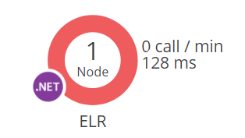

CampusServices:

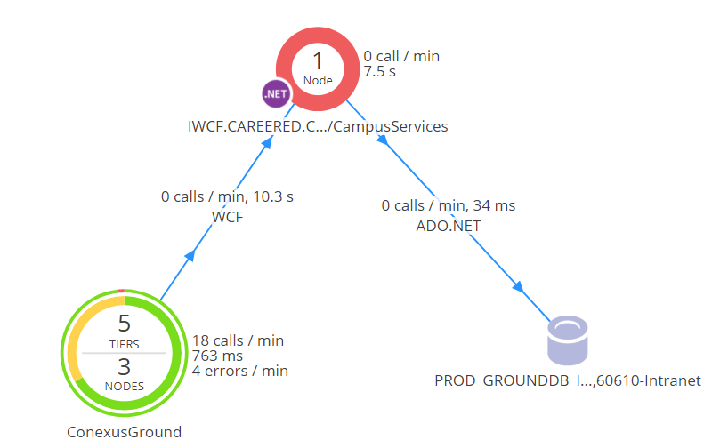



**CEC.Services.Authorization :**

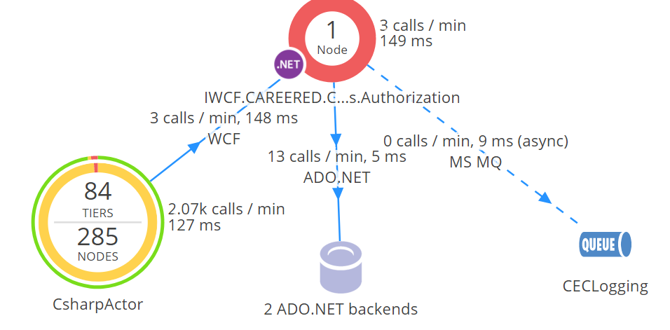

ADO.NET backends :

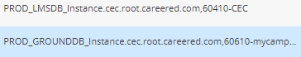

CEC.Services.CVue

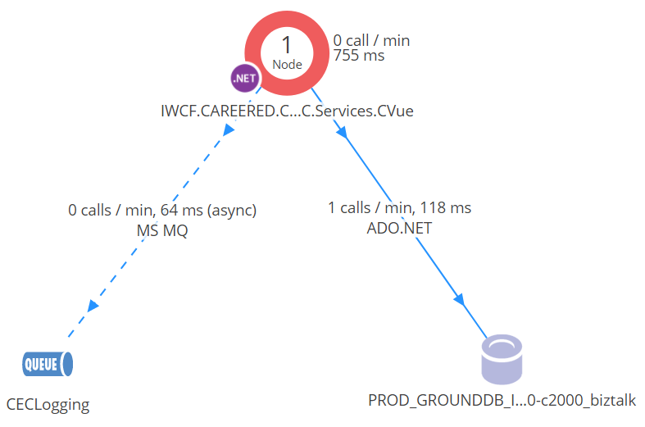



CEC.Services.Ground.AcademicAwards :

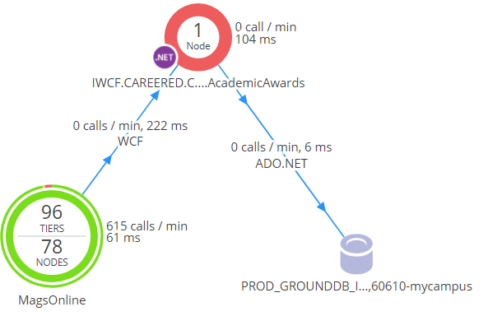



CEC.Services.Ground.common :

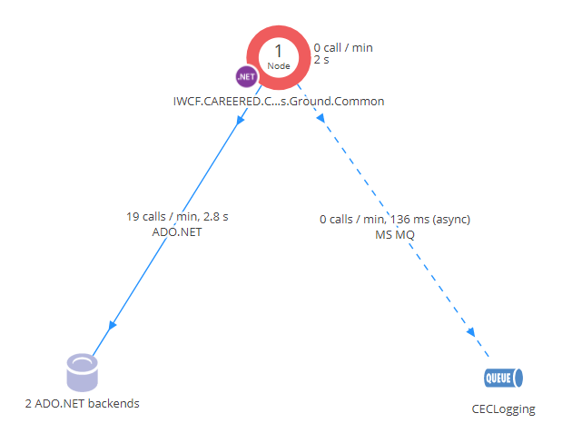

ADO.NET backends:

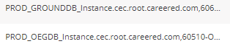

CEC.Services.Ground.Faculty.Personal :

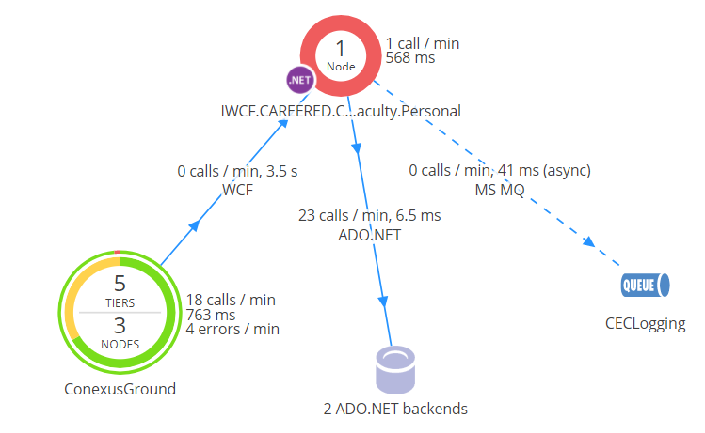

ADO.NET backends:

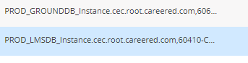

CEC.Services.Ground.NewFeeds :

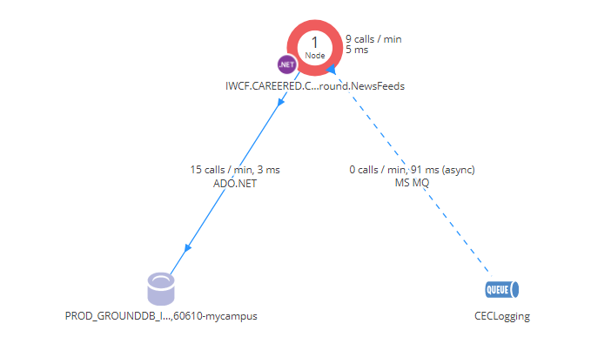



CEC.Services.Ground.School :

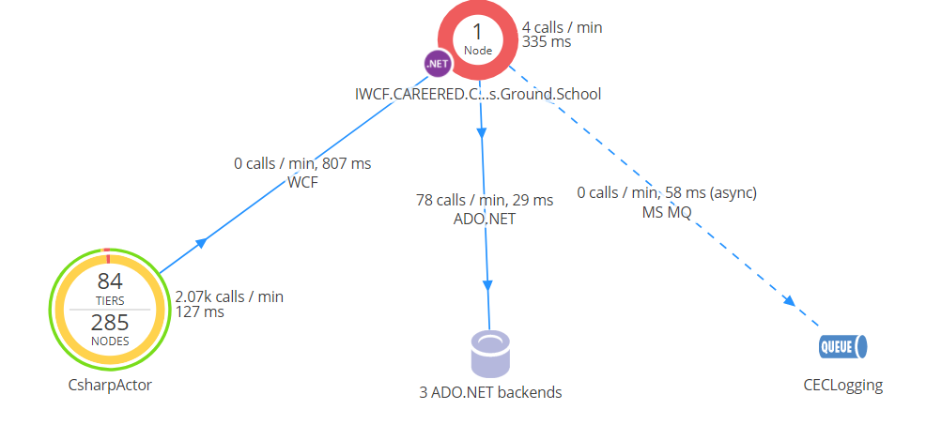

ADO.NET backends:

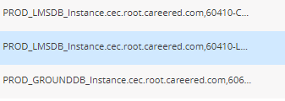

CEC.Services.Ground.Student.Academics :

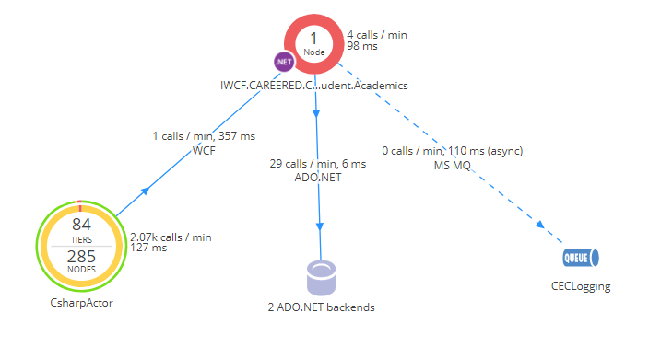

ADO.NET backends:

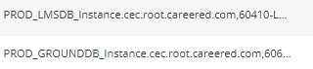

CEC.Services.Ground.Student.Financial :

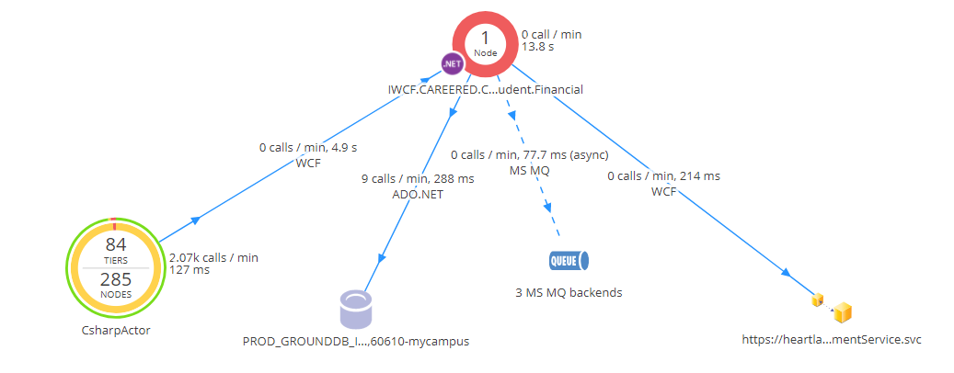



MS MQ backends:

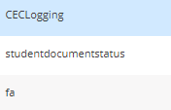

CEC.Services.Ground.Student.Payment :

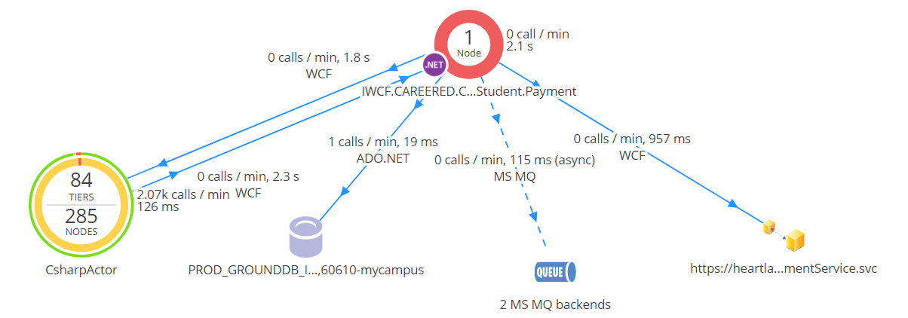



MS MQ backends:

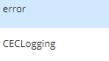



CEC.Services.Ground.Student.Personal :

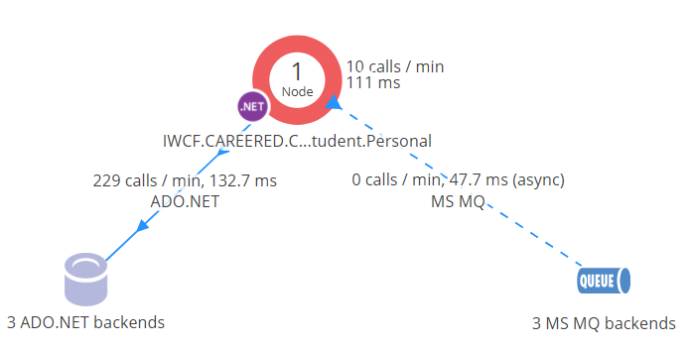

ADO.NET backends:

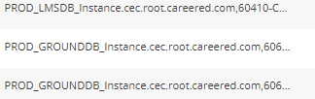

MS MQ backends:

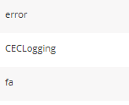

CEC.Services.Ground.Technical :

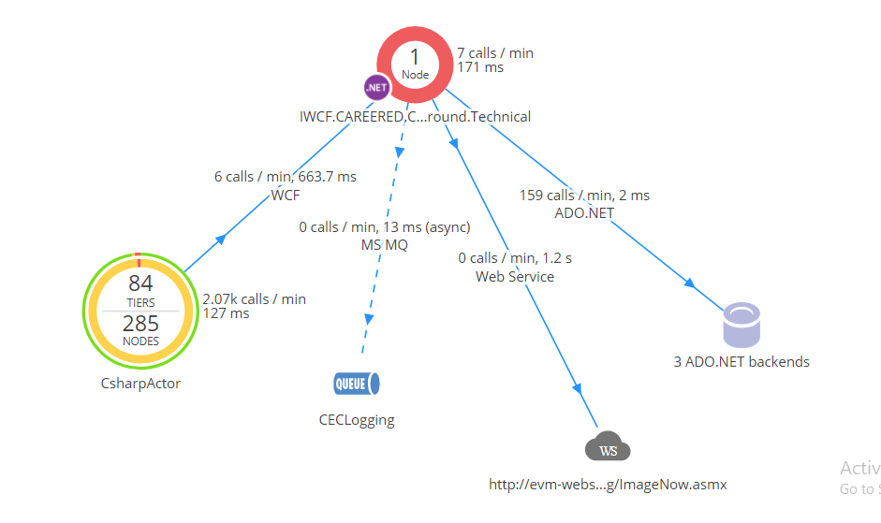



ADO.NET backends:

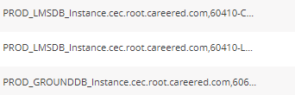

CEC.Services.Ground.User.Accounts :

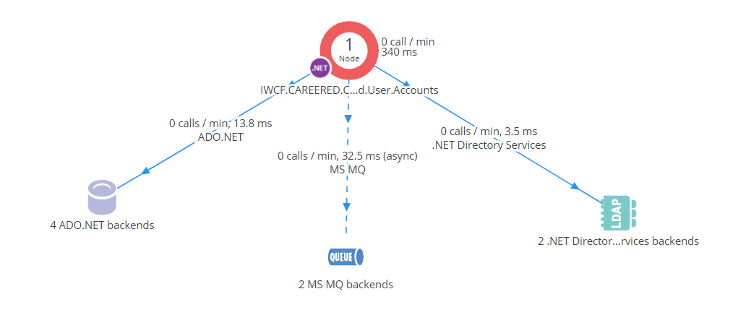

MS MQ backends:

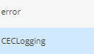

.Net Directories:

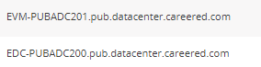

CEC.Services.Ground.Vendor :

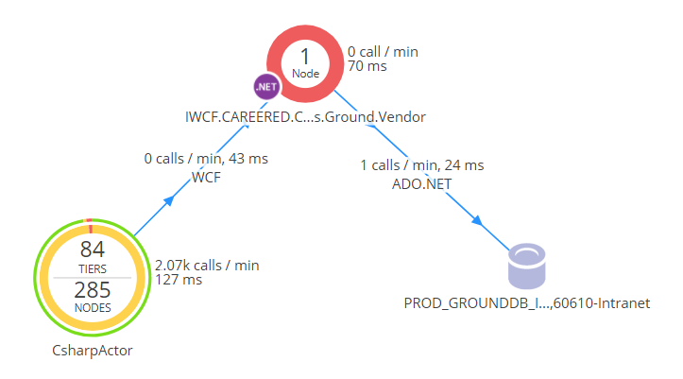



CEC.Services.LCS :

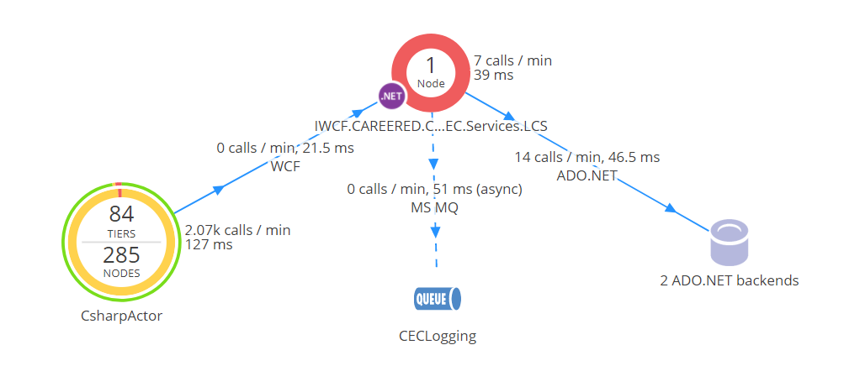

ADO.NET backends:

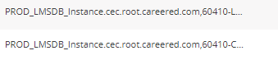

CEC.Services.LMS Common:

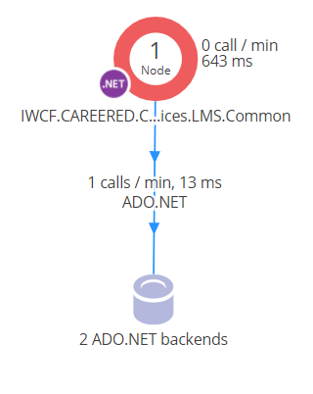

ADO.NET backends:

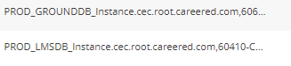

CEC.Services.LMS.Student.Academics:

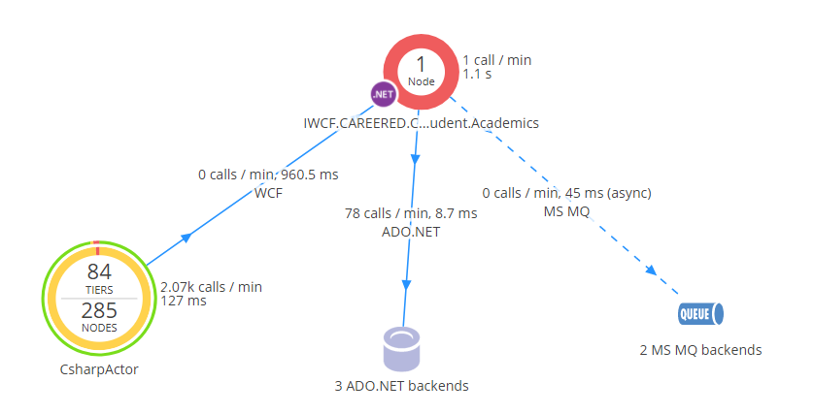

ADO.NET backends:

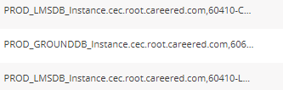

MS MQ backends:

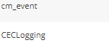

CEC.Services.School.Academic:

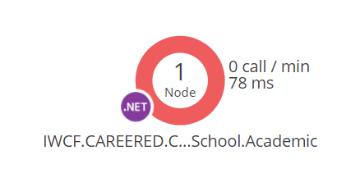

CEC.Services.School.LMS:

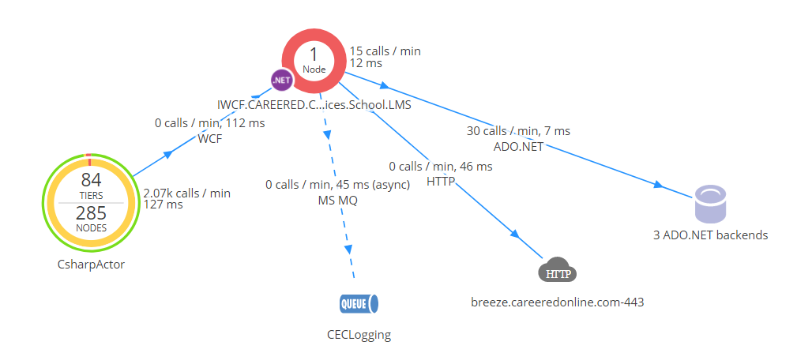

ADO.NET backends:

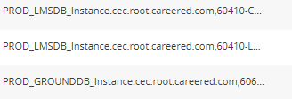

CEC.Services.Student.Academics.SAP:

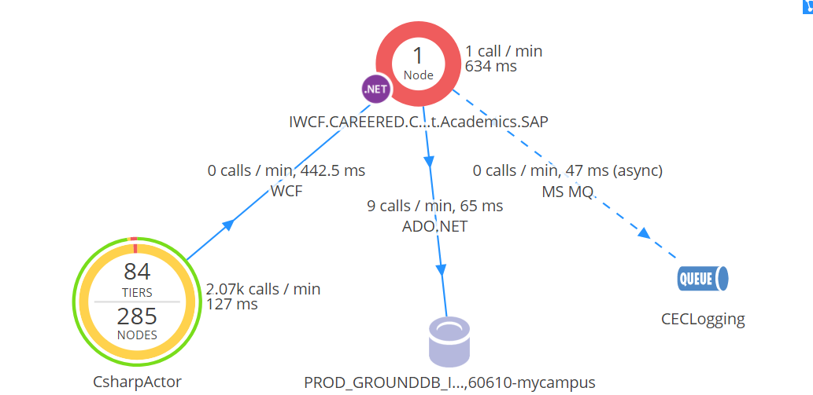



CEC.Services.Student.HostedEmail:

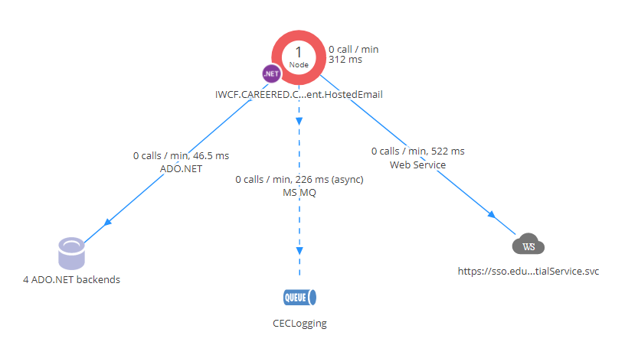

ADO.NET backends:

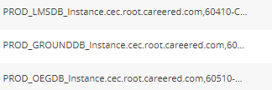





CEC.Services.Student.User.LMS:

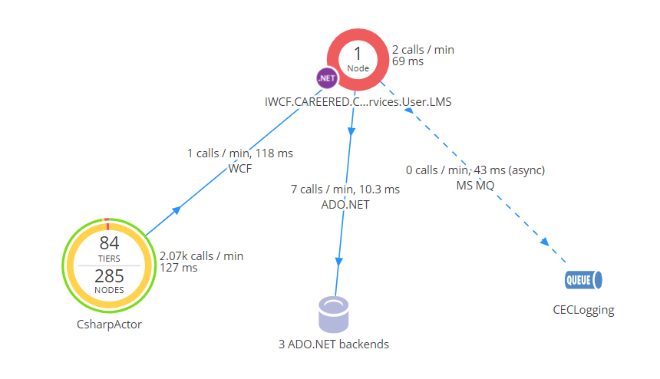

ADO.NET backends:

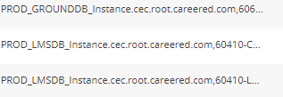

Ground.Student.CulinaryExternship:

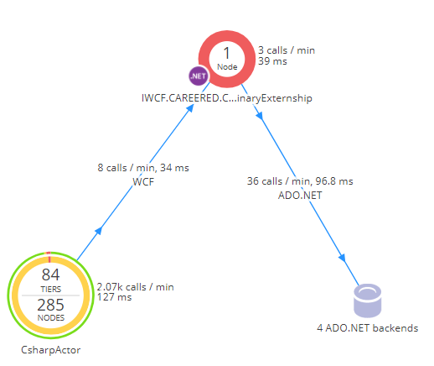

ADO.NET backends:

